**LAB : OBJECT ORIENTED PROGRAMMING (OOP)**

**Week # 04**

**EXERCISE**

Q1- Write a program that can calculate the factorial of a number by passing the address of that number to function, using pointers.

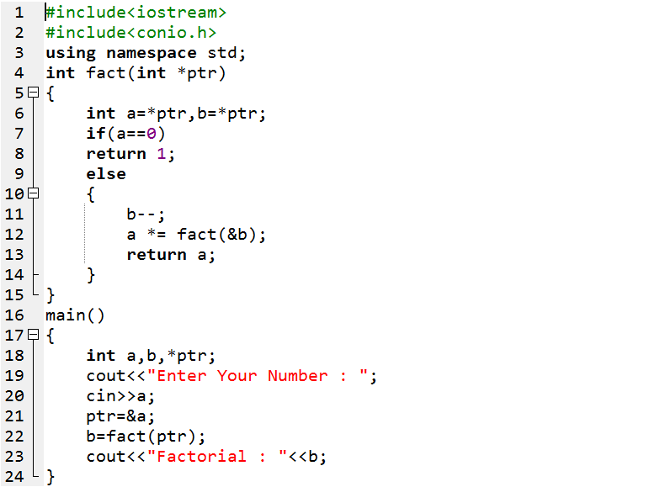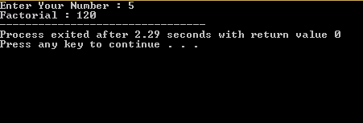

Q2- Write a program that will declare and initialize two arrays and would generate the sum of these two arrays by using pointers.

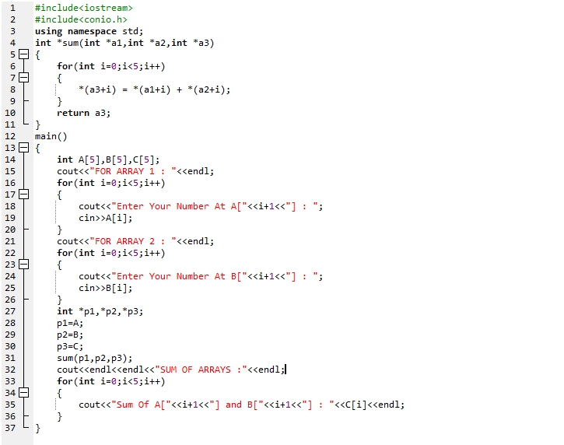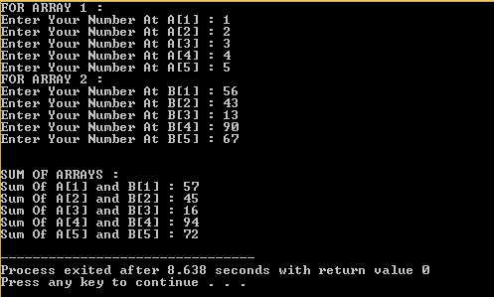

Q3- Write a program that will calculate the area of circle by using constant data member pi=3.14, and by using constant pointer.

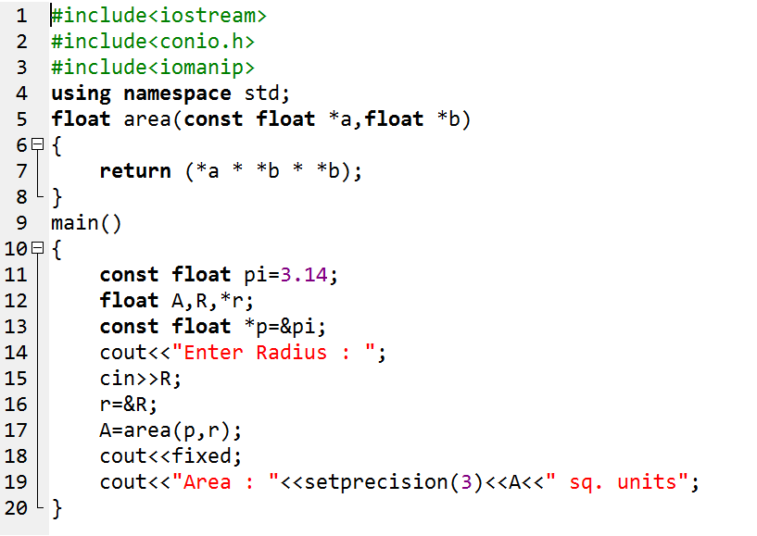

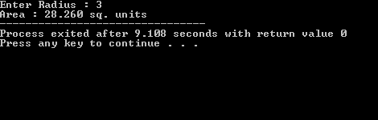

Q4- Write a program that would generate some table by using pointer.

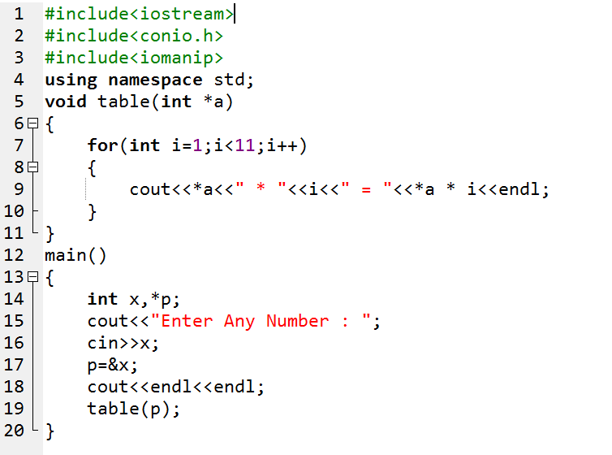

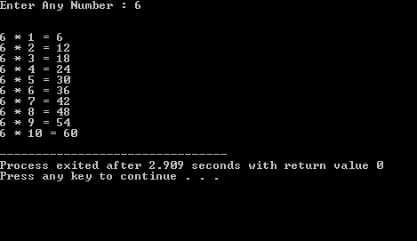

Q5- Write a program that would design simple calculator, by using pointer.

